TRAFFIC TREATMENTS PROPOSAL
INVITATION TO COMMENT
WHERE CAN I FIND FURTHER INFORMATION?

Full details of this project can be found on the City's website: www.wanneroo.wa.gov.au/yoursay

Details and plans can also be viewed at the Wanneroo Civic Centre, or the Girrawheen Library.

Please call the City's Transport and Traffic Team if you have any further queries on 9405 5000. Please quote 15/289894
PROPOSED CHANGES TO
TEMPLETON CRESCENT
What is happening?
The City is proposing to implement a Traffic Management Scheme along Templeton Crescent to help with; reducing vehicle speeds, reducing rat-running, improving traffic flow and improving pedestrian connectivity for residents living within the Girrawheen area. The works are programmed to be completed within the 2015/2016 financial year and will utilise a range of traffic treatment devices including raised median islands, street trees and speed cushions.
A concept plan detailing the proposed traffic management scheme and the locations of the devices is attached to this invitation to comment and is also available for viewing via the City's website at www.wanneroo.wa.gov.au/yoursay.
HOW DO I PROVIDE FEEDBACK?

» Online - visit https://www.surveymonkey.com/s/TempletonTMS and complete the online survey
Or
» Via post – handwrite your comments on the comment form enclosed and post it back to us

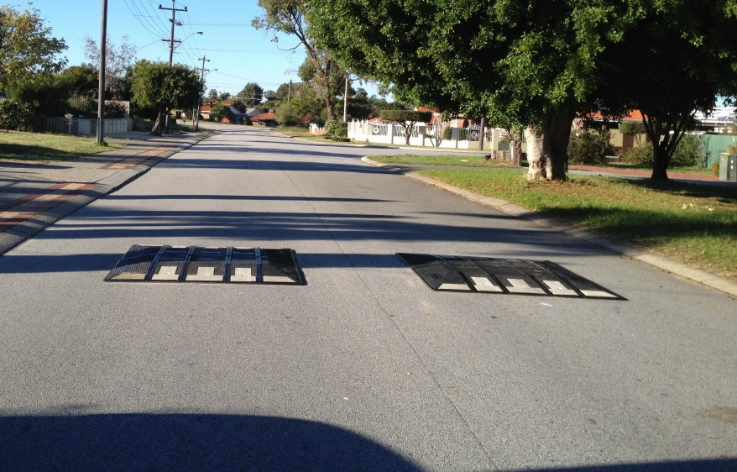
WHAT HAPPENS AFTER THE CONSULTATION?

If the project is supported by the community, the project will proceed and construction will be scheduled. If the community does not support the project, the results will be reported to Council and they will make a decision after considering the feedback received. Everyone that comments will receive notification of this decision via our Transport and Traffic Team. Thank you for taking the time to provide us with your comments.

Key Issues previously raised by the community:
- Safety of pedestrians and cyclists especially around the Girrawheen Shopping Precinct
- Rat Running / Shortcut movement traffic
- Volume and speed of traffic
- Hoon behaviour
www.wanneroo.wa.gov.au/yoursay

BUILDING LIVEABLE COMMUNITIES

What are we doing?
The treatments being considered are as pictures below and are located as shown on the attached concept plan. Please note that the proposed scheme also includes rubberised speed cushions pictured on the first page. Please review all the photo images to help you interpret what devices are proposed.
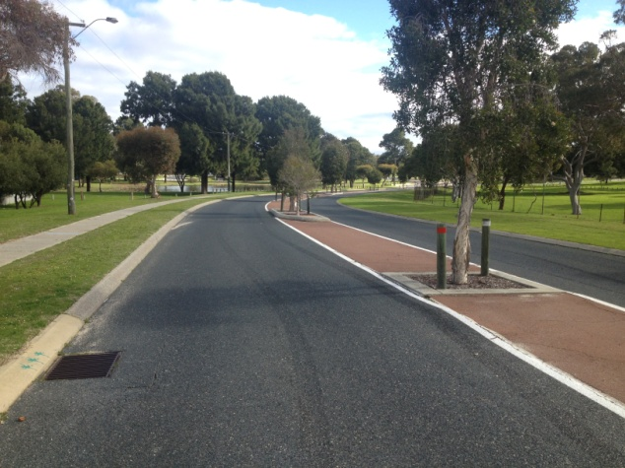
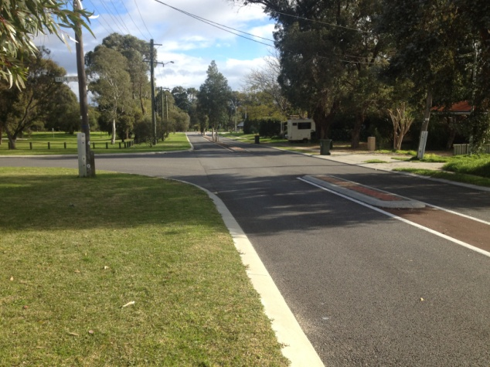

Median Islands

Street Trees

How did we come up with the proposed treatments?
City Traffic Engineers considered the key points raised and have developed potential measures to help address the problems, with a particular focus on the needs of the community and meeting engineering design requirements. We try to balance the needs and safety of our residents with those of commuters.

Why are we doing it?

Reconfiguring the layout of our streets by installing medians, street trees and other traffic treatments change the look and feel of a road so that the road better serves the people that use it whether that is drivers, pedestrians or cyclists. Below are a number of reasons why-

Creating safer streets for walking and cycling
- Kids who live in neighbourhoods not dominated by speeding traffic, have more opportunities for cycling, walking, access to parks and play spaces and have a wider set of friends (as do their families).

Enhancing Wanneroo Streetscapes
- The installation of street trees and landscaping improves the visual appearance of the road environment and also reduces the drivers’ visual field resulting in lower travel speeds.

Less vehicle conflicts
- Median islands remove the possibility of head on crashes as well as reduce the lane width of the road resulting in lower travel speeds
www.wanneroo.wa.gov.au/yoursay
Reducing Vehicle Speeds
- Vehicle speed affects both the risk of being involved in a crash and, more importantly, the severity of a crash. Installing traffic treatments reduces the likelihood and severity of crashes and also improves safety for pedestrians and cyclists.

Building on existing pathways and infrastructure
- Filling in crucial gaps in infrastructure makes sense. Installing medians, street trees and missing pathway links fits with the existing streetscapes within the Madeley and Darch areas.

