ROAD IMPROVEMENTS PROPOSAL
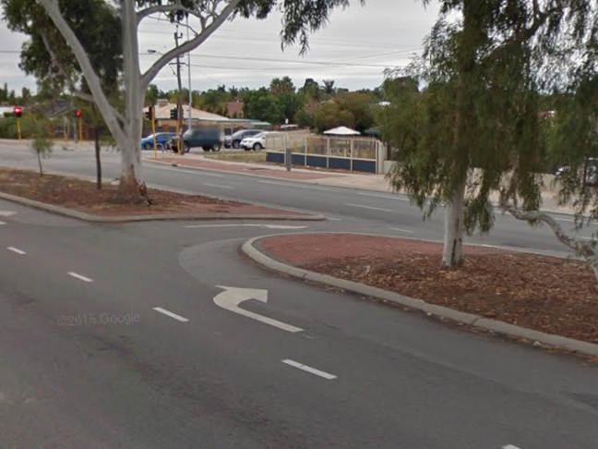
INVITATION TO COMMENT
PROPOSED CHANGES TO
MIRRABOOKA AVENUE
What is happening?
The City is proposing to make changes to the infrastructure along Mirrabooka Avenue in the vicinity of Mercy College to help improve the movement of traffic in the area at peak drop-off / pick-up periods.
The changes will include the following;
Photo 1
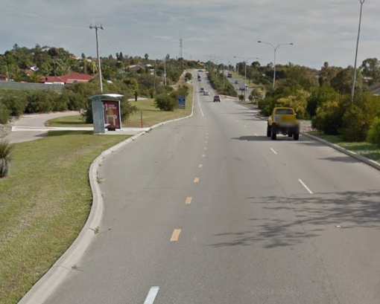
U-turn facility on Mirrabooka Avenue:
A car only U-turn facility is proposed to be installed on Mirrabooka Avenue between Golders Way and Chataway Road. The facility will enable a location for cars heading north along Mirrabooka Avenue to safely perform a U-turn and head south. Refer Photo 1 for an example of this type of facility.

Bus Embayment southbound only:
A bus embayment is proposed to be installed adjacent to Mercy College immediately south of Golders Way. The embayment will enable buses to move and stop off the carriageway and should improve the flow of southbound traffic. Refer Photo 2 for an example of Photo 2
this type of facility.
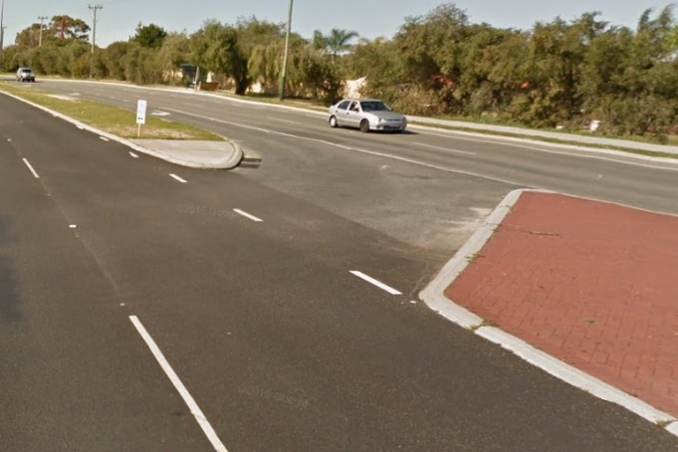
Golders Way intersection movement restrictions:
The Golders Way / Mirrabooka Avenue intersection will be modified to extend the median island into the intersection to restrict the ability for traffic exiting Golders Way to perform a right-turn exit movement. Residents wishing to head south will instead need to use the proposed U-turn facility proposed 100m north of the intersection. Refer Photo 3 for an example of this type of facility.
Photo 2

In addition to the above works, parking prohibitions will be applied to the verge to assist with compliance in regards to parking in the area. Concept plans detailing the proposed infrastructure changes and the proposed locations are attached to this invitation to comment and are also available for viewing via the City's website at www.wanneroo.wa.gov.au/yoursay.
www.wanneroo.wa.gov.au/yoursay
BUILDING safer COMMUNITIES

Why are we doing it?

Reconfiguring the access arrangements on Mirrabooka Avenue adjacent to Mercy College will remove some of the potential conflicts away from the Golders Way / Mirrabooka Avenue intersection. Ultimately this should result in a much safer road environment for all road users. Less conflict points means the road will better serve the people that use it whether that is drivers, pedestrians or cyclists.

How were the proposed changes selected?
City Traffic Engineers completed on-site inspections and met with representatives from Mercy College to discuss the movement of traffic and determine what solutions could be implemented to have the most benefit with as few negative consequences as possible. The selected options are considered to best address the issues with consideration of the needs of the community whilst also meeting engineering design requirements. The City tries to balance the needs and safety of its residents with those of commuters.
HOW DO I PROVIDE FEEDBACK?

» Online - visit https://www.surveymonkey.com/r/Mirrabooka by completing the online survey

Or

» Via post – handwrite your comments on the survey form enclosed and post it back to us in the supplied reply paid envelope

The survey period closes by COB on Monday 14 September 2015
WHERE CAN I FIND FURTHER INFORMATION?

Full details of this project can be found on the City's website: www.wanneroo.wa.gov.au/yoursay

Details and plans can also be viewed at the Wanneroo Civic Centre on request.

Please call the City's Transport and Traffic Team if you have any further queries on 9405 5000. Please quote 15/414836
www.wanneroo.wa.gov.au/yoursay
WHAT HAPPENS AFTER THE CONSULTATION?

If the project is supported by the community, the project will proceed and construction will be scheduled. If the community does not support the project, the results will be reported to Council and they will make a decision after considering the feedback received. Everyone that comments will receive notification of this decision via our Transport and Traffic Team. Thank you for taking the time to provide us with your comments.

