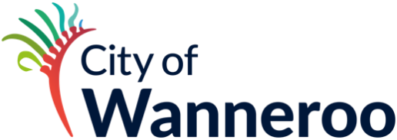

Expression of Interest

2024/25 Community & Sporting Clubs Showcase Event
Please complete this EOI to register your interest in coordinating the 2024/25 Community & Sporting Clubs Showcase Event.

APPLICANT INFORMATION
Organisation Name
ABN
Contact Person 1*
Position
Address
Postcode
Contact number
Email
* The Event License will be issued to this person

Contact Person 2
Position
Address
Postcode
Contact number
Email

PLEASE TELL US ABOUT YOUR ORGANISATION

- Please describe your group’s connection with community and sporting groups in the City of Wanneroo.

- Please describe your proposal for a 2024/25 Community & Sporting Clubs Showcase Event.

- Please tell us about your skills and experience in planning and delivering a successful community event.

- Have you identified any potential partnership and other funding sources?

